Project Design Phase
Solution Architecture

Date | 19 February 2026
Team ID | LTVIP2026TMIDS83753
Project Name | Weather-Based Prediction of Wind Turbine Energy Output: A Next-Generation Approach to Renewable Energy Management

Solution Architecture:
Solution architecture is a structured process that connects renewable energy management problems with intelligent technology solutions. In this project, the solution architecture bridges the gap between inaccurate wind energy forecasting and machine learning-based predictive systems.
- Identify an efficient machine learning solution to predict wind turbine energy output.
- Describe the structure, characteristics, and behavior of the web-based prediction system.
- Define system components including frontend, backend, and machine learning layers.
- Provide technical specifications for development, deployment, and scalability.

Example - Solution Architecture Diagram:
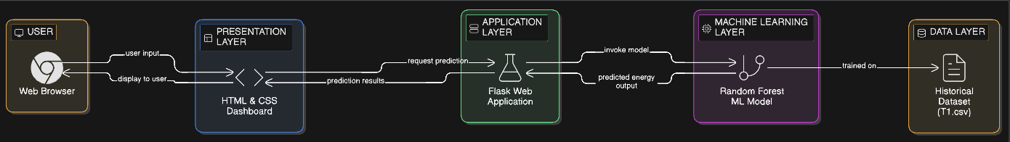

Figure 1: Architecture and data flow of the voice patient diary sample application
Reference: https://aws.amazon.com/blogs/industries/voice-applications-in-clinical-research-powered-by-ai-on-aws-part-1-architecture-and-design-considerations/

